PROJECT REPORT

Research on the Economic Impact of COVID-19
Focus Industry: Hospitality & Tourism Sector

Name: MD AFJAL KHAN
UID: 22BCA10598
Section: 2-B
Subject: Computing Aptitude
Technologies Used: Microsoft Word | Data Visualization | Statistical Analysis

1. Abstract
The COVID-19 pandemic triggered one of the most severe and unprecedented global economic crises in modern history, leaving virtually no industry untouched. This research report focuses on the Hospitality and Tourism sector — among the hardest-hit industries worldwide — and conducts a comprehensive analysis of the pandemic's economic effects on business operations, employment trends, and revenue streams.

Through descriptive statistical analysis, graphical data visualizations, and comparative industry benchmarking, this report quantifies the depth of the economic shock experienced between 2020 and 2022, and tracks the recovery trajectory through 2023. Key findings reveal that global hotel revenues plummeted by nearly 55% in 2020, the airline industry lost over $630 billion in revenue, and unemployment in the hospitality sector peaked at over 24% at the height of the pandemic. This report concludes with evidence-based recommendations for building economic resilience and guiding future policy decisions within the sector.

2. Introduction
The outbreak of SARS-CoV-2, commonly known as COVID-19, was officially declared a global pandemic by the World Health Organization (WHO) on March 11, 2020. Within weeks, governments across the world imposed sweeping lockdowns, travel bans, and social-distancing mandates in a bid to contain the virus. While these public health measures were necessary, they simultaneously delivered a catastrophic blow to the global economy.

The Hospitality and Tourism industry — which encompasses hotels, airlines, restaurants, event management, and recreational services — proved especially vulnerable. Unlike manufacturing or technology sectors that could partially adapt to remote operations, hospitality by definition requires physical presence and human interaction. The resulting collapse in consumer demand, international travel, and in-person events led to sudden and massive revenue losses.

This report aims to:
- Quantify the economic impact of COVID-19 on the Hospitality and Tourism industry
- Analyze shifts in employment patterns and business closures
- Examine revenue decline trends across key sub-sectors
- Track the recovery trajectory from 2021 to 2023
- Provide strategic recommendations for resilience and future preparedness

3. Industry Overview

3.1 About the Hospitality & Tourism Industry
The global Hospitality and Tourism industry was valued at approximately $9.6 trillion in 2019, contributing around 10.4% of global GDP and supporting over 330 million jobs worldwide, according to the World Travel & Tourism Council (WTTC). The sector encompasses a diverse range of sub-industries:
- Hotels, resorts, and accommodation services
- Commercial aviation and air travel
- Food and beverage / restaurant services
- Entertainment, events, and conferences
- Travel agencies and tour operators

3.2 Pre-COVID Economic Performance
The table below summarizes key economic indicators for the Hospitality & Tourism sector before the pandemic (2017–2019):

Indicator | 2017 | 2018 | 2019
Global Tourism Revenue (USD Trillion) | $7.6T | $8.8T | $9.6T
International Tourist Arrivals (Billion) | 1.32B | 1.40B | 1.46B
Industry Contribution to Global GDP (%) | 10.2% | 10.4% | 10.4%
Total Employment (Million Jobs) | 313M | 320M | 334M
Hotel Occupancy Rate (Global Avg) | 68.2% | 69.5% | 71.0%
Table 1: Pre-COVID Economic Performance of the Hospitality & Tourism Sector

4. Economic Impact Analysis

4.1 Impact on Global GDP
COVID-19 caused the sharpest contraction in global GDP since the Great Depression. The world economy shrank by an estimated 3.4% in 2020, recovering modestly to +5.7% in 2021 as vaccination campaigns accelerated. The chart below illustrates GDP growth trends from 2017 to 2023:

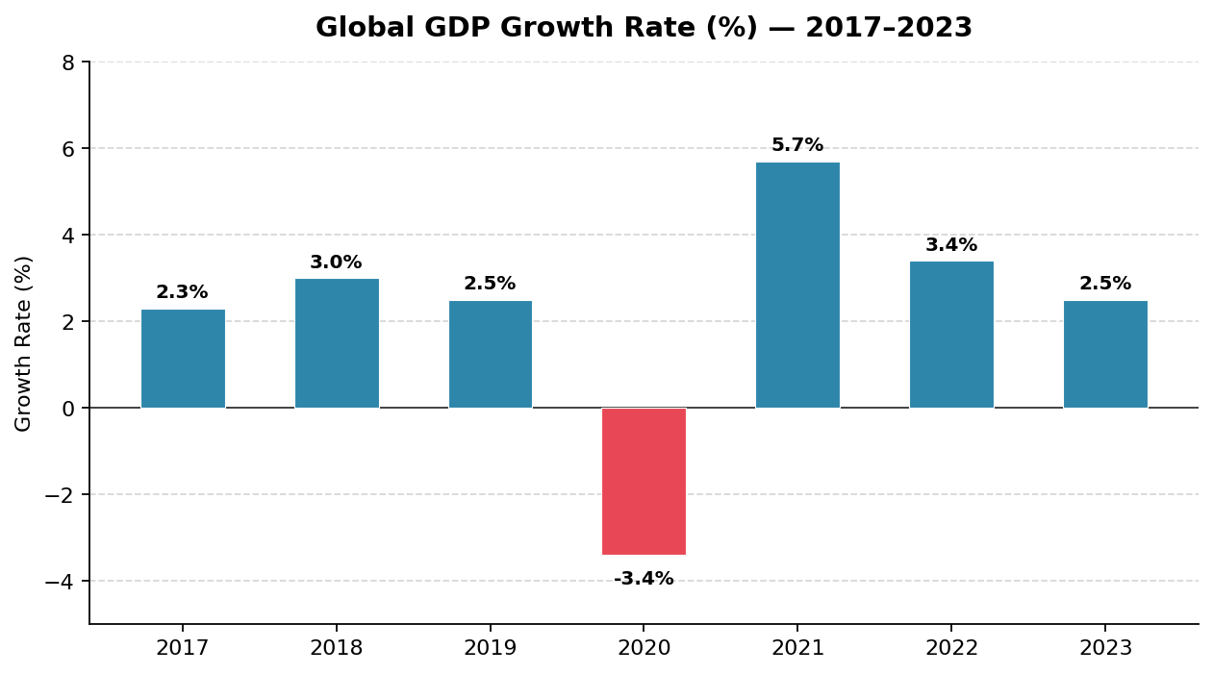
Figure 1: Global GDP Growth Rate (%) — 2017 to 2023
The 2020 contraction was especially devastating for tourism-dependent economies such as Thailand (GDP -6.1%), Spain (-10.8%), Greece (-8.2%), and the Maldives (-32%). For these nations, the near-complete halt in international travel directly translated to massive fiscal shortfalls and rising sovereign debt.

4.2 Revenue Decline Across Sub-Sectors
The revenue impact was felt across every sub-sector of hospitality. Hotel revenues declined globally by approximately 55% in 2020, while the airline industry suffered losses exceeding $630 billion. The line chart below compares pre-pandemic and post-pandemic revenue trajectories:

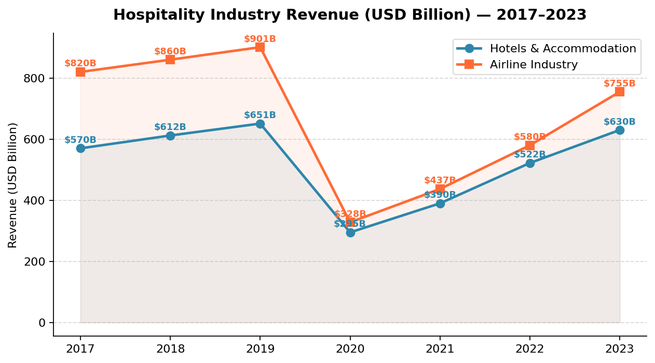
Figure 2: Hospitality Industry Revenue (USD Billion) — Hotel vs. Airline Sectors (2017–2023)
The revenue drop was most severe in Q2 2020 (April–June), during which global lockdowns were at their strictest. International borders were largely closed, leisure and business travel came to a near-complete standstill, and hotel occupancy rates plummeted to single digits in major travel destinations.

4.3 Distribution of Revenue Loss by Sub-Sector
The following pie chart illustrates how the total revenue losses in 2020 were distributed across the major sub-sectors of the Hospitality and Tourism industry:

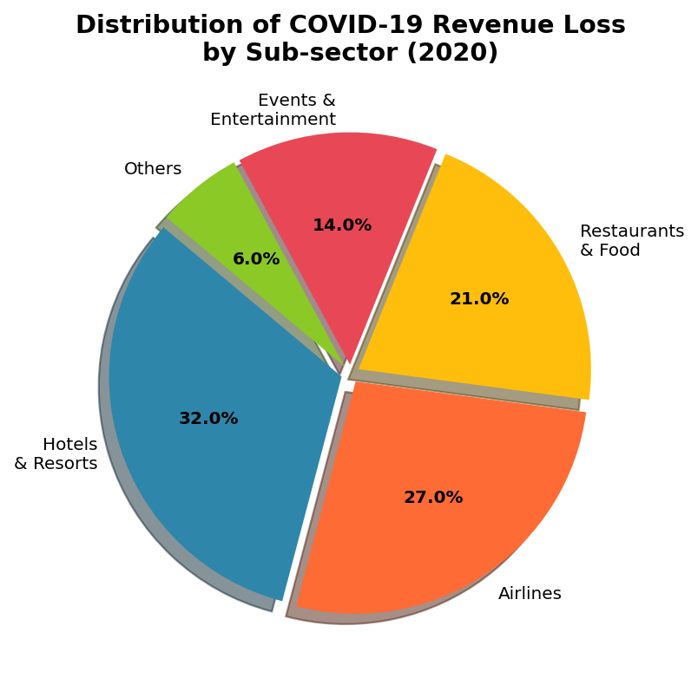
Figure 3: Distribution of COVID-19 Revenue Loss by Sub-Sector (2020)
Hotels and resorts absorbed the largest share (32%) of total industry losses, followed closely by airlines (27%). The food & restaurant sector contributed 21% of losses largely due to forced closures and capacity restrictions. Events and entertainment — including concerts, MICE (Meetings, Incentives, Conferences, and Exhibitions) — accounted for 14% of sector losses.

5. Employment Impact

5.1 Unemployment Rate by Industry
The pandemic caused a dramatic surge in unemployment across all sectors, but the hospitality industry bore the most severe impact. Pre-pandemic unemployment in hospitality stood at approximately 4.5%; by mid-2020, this had spiked to over 24% as businesses shut down and workers were furloughed or laid off.

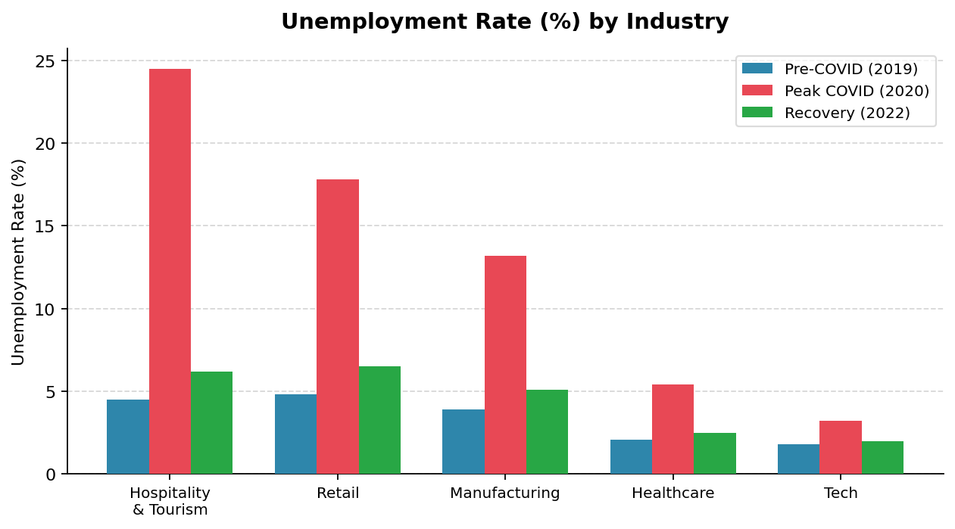
Figure 4: Unemployment Rate (%) by Industry — Pre-COVID vs. Peak COVID vs. Recovery
In contrast, the technology sector saw minimal unemployment rise (from 1.8% to 3.2%), reflecting the ability of knowledge-based industries to transition to remote work. Healthcare employment actually surged during the crisis, highlighting the uneven economic geography of the pandemic's labor market impact.

5.2 Sector-wise Employment Data (2019–2022)
The following table summarizes employment figures across critical hospitality sub-sectors:

Sub-Sector | 2019 (Pre-COVID) | 2020 (Peak Impact) | 2021 (Recovery) | 2022
Hotels & Accommodation | 16.4M | 9.2M | 11.8M | 14.5M
Airlines & Air Travel | 11.2M | 5.8M | 7.4M | 9.6M
Restaurants & Food Service | 54.0M | 32.5M | 42.0M | 50.1M
Events & Entertainment | 8.6M | 2.1M | 4.5M | 7.0M
Travel Agencies | 6.3M | 3.0M | 4.2M | 5.8M
TOTAL | 96.5M | 52.6M | 69.9M | 87.0M
Table 2: Employment Figures by Hospitality Sub-Sector (Million Workers)

Overall, the Hospitality and Tourism industry lost approximately 44 million jobs at peak pandemic impact in 2020 — a staggering 45.6% reduction from pre-pandemic employment levels. While recovery has been underway, the sector had not fully restored pre-pandemic employment levels by 2022.

6. Impact on Businesses

6.1 Business Closures and Financial Distress
The economic shock of COVID-19 forced a large number of hospitality businesses into permanent closure. According to the WTTC and various national business surveys, the following scale of closures was recorded globally:
- Approximately 1 in 6 hotels globally were permanently closed by end of 2020
- Over 40% of independent restaurants in developed economies did not reopen
- More than 50 airlines either went bankrupt or required government bailouts
- Thousands of travel agencies and tour operators ceased operations permanently

6.2 Financial Support Measures
Governments worldwide introduced emergency financial support packages to prevent complete industry collapse. The table below summarizes key relief measures implemented:

Country / Region | Relief Measure | Estimated Value
United States | Paycheck Protection Program (PPP) + Airline Grants | $900B (Total Stimulus)
European Union | Recovery and Resilience Facility (RRF) | $750B EUR
United Kingdom | Coronavirus Job Retention Scheme (Furlough) | $70B GBP
India | PM Garib Kalyan Yojana + Credit Guarantee Schemes | $266B USD equiv.
UAE / Middle East | Tourism sector waivers and fee reductions | $10B+ USD
Table 3: Government Financial Relief Measures for the Hospitality Sector

While these stimulus packages provided critical life support, many small and medium-sized enterprises (SMEs) — which form the backbone of the hospitality sector — struggled to access relief due to bureaucratic delays, stringent eligibility criteria, and pre-existing debt burdens.

7. Industry Recovery Analysis

7.1 Recovery Trajectory (2020–2022)
The industry's recovery has been gradual and uneven. Domestic tourism rebounded faster than international travel, and leisure travel recovered ahead of corporate business travel. The recovery index chart below tracks the pace of return to pre-pandemic business volumes:

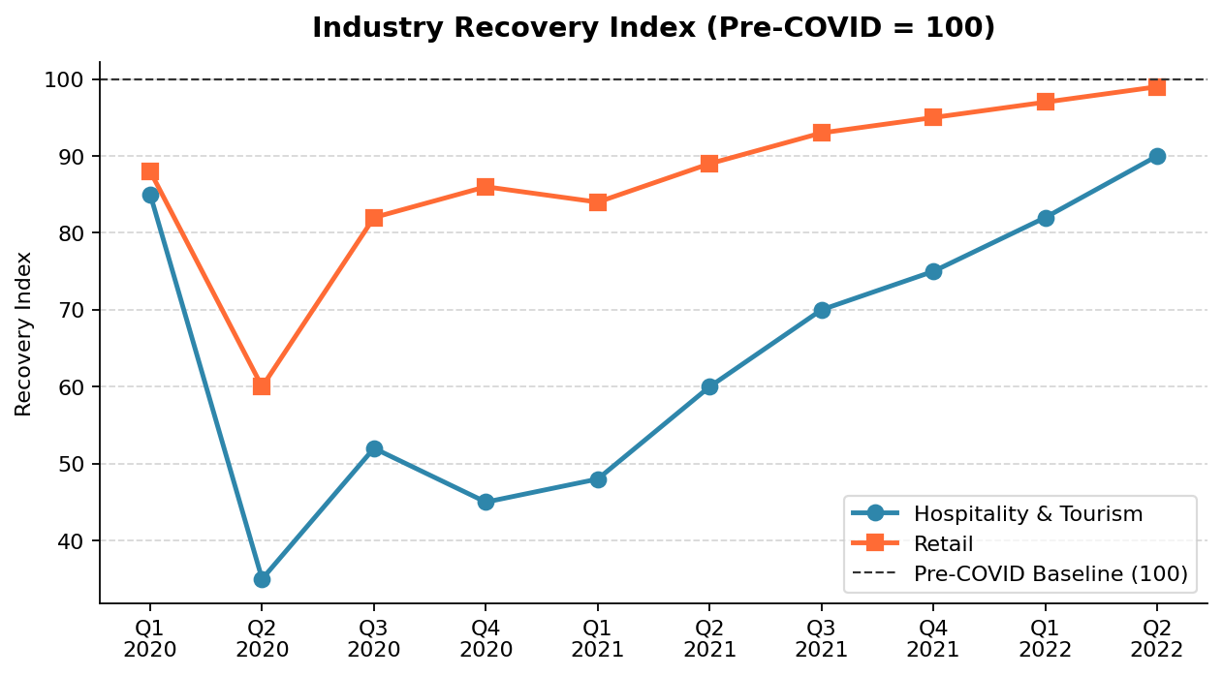
Figure 5: Industry Recovery Index (Pre-COVID Baseline = 100) — Q1 2020 to Q2 2022
The retail sector recovered to near pre-pandemic levels by early 2022, driven by pent-up consumer demand and robust e-commerce growth. The hospitality and tourism sector, however, lagged significantly due to continued international travel restrictions, shifting consumer confidence, and the emergence of new virus variants (Delta, Omicron) that repeatedly disrupted travel corridors.

7.2 Key Recovery Drivers
Several factors have supported the partial recovery of the hospitality industry:
- Accelerated global vaccination campaigns increasing traveler confidence
- Reopening of international borders and easing of visa restrictions
- Revenge travel phenomenon — pent-up demand for leisure and holidays
- Digital transformation and contactless service adoption
- Government tourism promotion campaigns and subsidized travel initiatives
- Flexible booking and cancellation policies introduced by hotels and airlines

8. Conclusion
This research report has examined the multidimensional economic impact of COVID-19 on the Hospitality and Tourism industry — one of the world's largest and most employment-intensive sectors. The findings confirm that the pandemic caused an economic rupture of historic proportions, resulting in massive revenue losses, widespread unemployment, and a wave of business closures.

Key conclusions drawn from this analysis include:
- Global hospitality revenues declined by over 50% in 2020, representing losses of trillions of dollars
- Employment in the sector fell by approximately 45% at peak crisis, with over 44 million jobs lost globally
- Hotel occupancy rates collapsed from 71% (2019) to under 25% (2020) in most major markets
- Airlines required unprecedented government bailouts to avoid systemic collapse
- Recovery has been gradual, with full restoration of pre-pandemic performance expected only by 2024–2025

The pandemic has also accelerated structural changes within the industry — including digital check-in systems, hybrid events, sustainable tourism practices, and diversified revenue models — that are likely to reshape the sector permanently. The lessons learned underscore the urgent need for robust crisis-preparedness frameworks, diversified market strategies, and stronger public-private partnership mechanisms within the hospitality ecosystem.

This research affirms the critical importance of data-driven analysis in understanding economic disruptions and crafting effective responses. As the world continues to recover, the insights generated through studies such as this will be invaluable in guiding policymakers, business leaders, and researchers toward a more resilient and sustainable global tourism economy.

End of Report

